

Practices for Lesson 2:
Creating a Multitenant
Container Database and
Pluggable Databases
Chapter 2

Practices for Lesson 2
Practices Overview
In this practice you will create a new CDB named cdb1 with DBCA with no PDB except the
seed.
After the CDB creation is completed, check the physical and logical structures of the new CDB.
Then, you will create several PDBs using different methods.
Create pdb1_1 from seed in cdb1.
Clone pdb1_2 in cdb1 from pdb1_1.
Plug the non-CDB orcl2 into the CDB cdb1 as pdb_orcl2.
Merge the two CDBs cdb1 and orcl12c into cdb1, and optionally drop the database
cdb1 (optional practice).
Finally, you drop the pdb1_2 using either DBCA or SQL Developer or SQL*Plus after the
creation of this PDB.
Practice 2-1: Creating a New CDB
Overview
In this practice, you will create a new CDB named cdb1 with DBCA.
Assumptions
The created CDB orcl12c already exists.
Tasks
1. Create a CDB named cdb1 using DBCA. First release resources held by other instances,
shutting down the orcl12c and pec1 instances.
a. Shut down orcl12c by bringing up sqlplus via your desktop. Login as:
\@orcl12c as sysdba
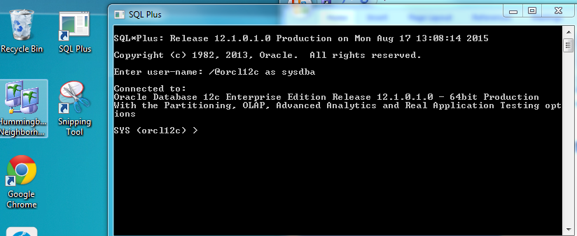
Connected to:
Oracle Database 12c Enterprise Edition Release 12.1.0.0.2 -64bit Production
With the Partitioning, OLAP, Data Mining, Real Application
Testing
SQL> SHUTDOWN IMMEDIATE
Database closed.
Database dismounted.
ORACLE instance shut down.
SQL> EXIT
b. Shut down pec1. by connecting through the current sqlplus session:
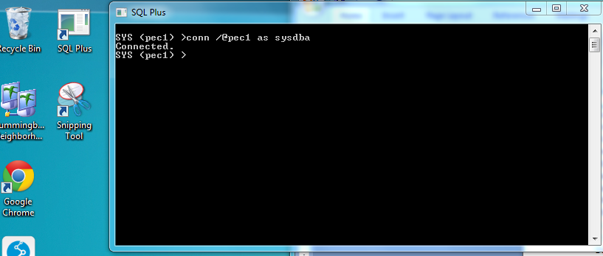
OR you can connect via command prompt as shown:
C:\ora12clabs sqlplus /@pec1 as sysdba
Connected to:
Oracle Database 12c Enterprise Edition Release 12.1.0.0.2 -
64bit Production
With the Partitioning, OLAP, Data Mining, Real Application
Testing
SQL> SHUTDOWN IMMEDIATE
Database closed.
Database dismounted.
ORACLE instance shut down.
SQL> EXIT
c:\ora12clabs

d. Start dbca and perform the following steps.
start | all programs | Oracle - OraDBHome1 | Configuration Migration Tools | Database Configuration Assistant

Step Window\Page Description Choices or Values

a. Step 1: Database Operation Select “Create Database”.| Click Next.
b. Step 2: Creation Mode Select “Advanced Mode”.| Click Next.
c. Step 3: Database Template Select “General Purpose or Transaction
Processing”. | Click Next.
d. Step 4: Database Identification Enter Global Database Name: cdb1 | SID: cdb1
Select “Create As Container Database”
Select “Create An Empty Container Database”
Click Next.
e. Step 5: Management Options Deselect “Configure Enterprise Manager (EM)
Database Express”. | Click Next.
f. Step 6: Database Credentials Select “Use same Administrative password…”
Enter:
Password: password
Confirm password: password
Click Next.
g. Step 7: Network Configuration Listener Selection: Click Next
Step Window\Page Description Choices or Values

h. Step 8: Storage Locations Confirm Storage type is “File System”.
Select “Use Common Location for All Database
Files”.
Click Next.
i. Step 9: Database Options Click Next.
j. Step 10: Initialization Parameters Select “Character Sets”.
Select “Use Unicode (AL32UTF8)”.
Click Next.
k. Step 11: Creation Option Select “Create Database”.
Click Next.
l. Step 12: Pre Requisite Checks Click Next.
m. Step 13: Summary Click Finish.
n. Step 14: Progress Page On the Database Configuration Assistant page (for
password management) click Exit.
Click Close.

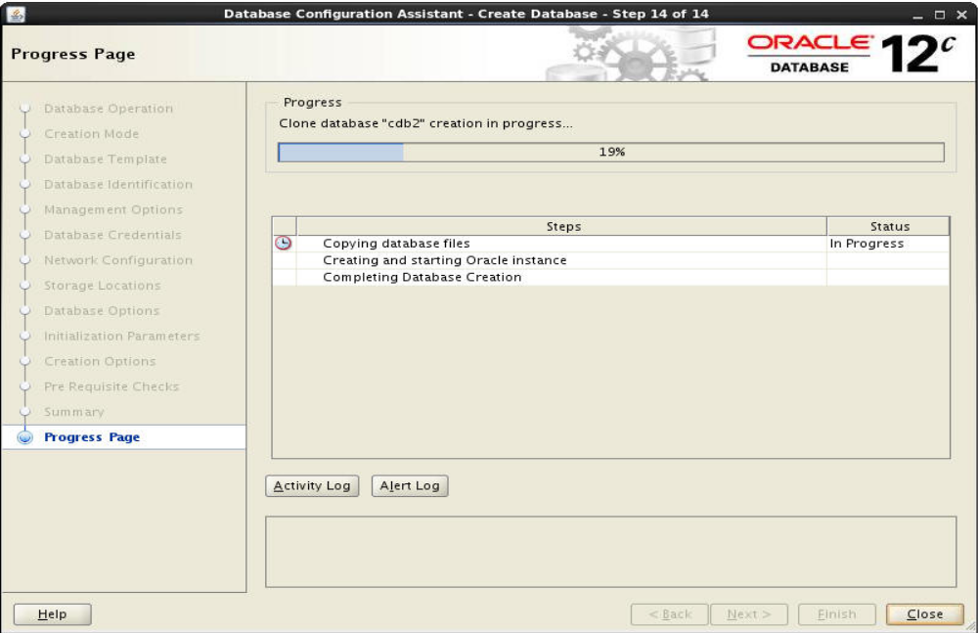

Practice 2-2: Exploring CDB and PDB Structures
Overview
In this practice, you check the physical and logical structures of the new CDB cdb1 and its seed PDB.
Tasks
1. Connect to the multitenant container database cdb1.
From the desktop connect to: /@cdb1 as sysdba
Connected to:
Oracle Database 12c Enterprise Edition Release 12.1.0.0.2 -
64bit Production
With the Partitioning, OLAP, Data Mining and Real Application
Testing options
SQL>

a. Check if the database is a multitenant container database
.
SQL> SELECT name, cdb, con_id from v$database;
NAME CDB CON_ID
--------- --- ----------
CDB1 YES 0
SQL>
b. Check the instance name.
SQL> SELECT INSTANCE_NAME, STATUS, CON_ID from v$instance;
INSTANCE_NAME STATUS CON_ID
---------------- ------------ ----------
cdb1 OPEN 0
SQL> EXIT
c. To check Oracle Network services.

$ /ora12clabs lsnrctl status
LSNRCTL for WIndows Version 12.1.0.1.0 - Production on 07-SEP-2012 01:10:16
Copyright (c) 1991, 2012, Oracle. All rights reserved.
Connecting to
(DESCRIPTION=(ADDRESS=(PROTOCOL=IPC)(KEY=EXTPROC1521)))
STATUS of the LISTENER
------------------------
Alias LISTENER
Version TNSLSNR for Windows: Version 12.1.0.1.0
- Production
Start Date 14-SEP-2012 03:04:56
Uptime 16 days 21 hr. 48 min. 35 sec
Trace Level off
Security ON: Local OS Authentication
SNMP OFF
Listener Parameter File C:c:\app\oracle\product\12.1.0\dbhome_1\network\admin\listener.ora
Listener Log File C:c:\app\oracle\product\12.1.0\dbhome_1\log\diag\tnslsnr
\101-14\listener\alert\log.xml
Listening Endpoints Summary...
DESCRIPTION=(ADDRESS=(PROTOCOL=ipc)(PIPENAME=\\.\pipe\EXTPROC1521ipc))
(DESCRIPTION=(ADDRESS=(PROTOCOL=tcp)(HOST=101-14)(PORT=1521)))
(DESCRIPTION=(ADDRESS=(PROTOCOL=tcp)(HOST=127.0.0.1)(PORT=1521)))
(DESCRIPTION=(ADDRESS=(PROTOCOL=tcps)(HOST=101-14)(PORT=5500)) (Security=(my_wllet_directory=C:c:\app\ORACLE\admin\orcl12c\xdb_wallet))(Presentation=HTTP)(Sesson=RAW))
(DESCRIPTION=(ADDRESS=(PROTOCOL=tcps)(HOST=101-14)(PORT=5501)) (Security=(my_wllet_directory=C:c:\app\ORACLE\admin\oms_db\xdb_wallet))(Presentation=HTTP)(Sessin=RAW))
(DESCRIPTION=(ADDRESS=(PROTOCOL=tcps)(HOST=101-14)(PORT=5502)) (Security=(my_wllet_directory=C:c:\app\ORACLE\admin\pec1\xdb_wallet))
(Presentation=HTTP)(SessionRAW))
Services Summary...
Service "CLRExtProc" has 1 instance(s).
Service "cdb1" has 1 instance(s).
Instance "cdb1", status READY, has 1 handler(s) for this service...
Service "cdb1XDB" has 1 instance(s).
Instance "cdb1", status READY, has 1 handler(s) for this service...
Instance "CLRExtProc", status UNKNOWN, has 1 handler(s) for this service
Service "oms_db" has 2 instance(s).
Instance "OMS_DB", status UNKNOWN, has 1 handler(s) for this service...
Instance "omsdb", status READY, has 1 handler(s) for this service...
Service "omsdbXDB" has 1 instance(s).
Instance "omsdb", status READY, has 1 handler(s) for this service...
Service "orcl12c" has 2 instance(s).
Instance "orcl12c", status UNKNOWN, has 1 handler(s) for this service...
Instance "orcl12c", status READY, has 1 handler(s) for this service...
Service "orcl12cXDB" has 1 instance(s).
Instance "orcl12c", status READY, has 1 handler(s) for this service...
Service "pdborcl" has 2 instance(s).
Instance "orcl12c", status READY, has 1 handler(s) for this service...
Instance "pdborcl", status UNKNOWN, has 1 handler(s) for this service...
Service "pec1" has 1 instance(s).
Instance "pec1", status READY, has 1 handler(s) for this service...
Service "pec1XDB" has 1 instance(s).
Instance "pec1", status READY, has 1 handler(s) for this service...
The command completed successfully

C:\ora12clabs> Connect to sql*plus through your Windows Desktop.

Connected to:
Oracle Database 12c Enterprise Edition Release 12.1.0.1.0 -64bit Production
With the Partitioning, OLAP, Advanced Analytics and Real
Application Testing options

SQL> col name format A20
SQL> SELECT name, con_id from v$services;
NAME CON_ID
-------------------- ----------
cdb1XDB 1
cdb1 1
SYS$BACKGROUND 1
SYS$USERS 1
SQL>

Notice that PDB$SEED service is not listed. No one should connect to this service because
there should be no operation performed on this container. It is reserved as a template to
create other PDBs.
3. Display the pluggable databases. Use a new view V$PDBS.

SQL> SELECT CON_ID, NAME, OPEN_MODE from v$pdbs;
CON_ID NAME OPEN_MODE
---------- ------------------------------ ----------
2 PDB$SEED READ ONLY
SQL>
Notice that the seed PDB is in READ ONLY open mode.
4. View new family of views CDB_xxx:

SQL> connect / as sysdba
Connected.
SQL> col PDB_NAME format a8
SQL> col CON_ID format 999999
SQL> SELECT PDB_ID, PDB_NAME, DBID, GUID, CON_ID
2 from cdb_pdbs order by 1;

PDB_ID PDB_NAME DBID GUID CON_ID
------ -------- ---------- ---------------------------- ------
2 PDB$SEED 4012275228 203F5F3EDB7F0000000000000000 1
SQL>

5. Check all files of the CDB.
a. View the redo log files of the CDB.

SQL> col MEMBER format A42
SQL> SELECT GROUP#, MEMBER, CON_ID from v$logfile;
GROUP# MEMBER CON_ID
---------- ------------------------------------------ -------
3 c:\app\oracle\oradata\cdb1\redo03.log 0
2 c:\app\oracle\oradata\cdb1\redo02.log 0
1 c:\app\oracle\oradata\cdb1\redo01.log 0
SQL>
b. View the control files of the CDB.

SQL> col name format A55
SQL> SELECT name, con_id from v$controlfile;
NAME CON_ID
------------------------------------------------------- -------
c:\app\oracle\oradata\cdb1\control01.ctl 0
c:\app\oracle\fast_recovery_area\cdb1\control02.ctl 0
SQL>

c. View all data files of the CDB, including those of the root and all PDBs, with
CDB_DATA_FILES view.

SQL> col file_name format A65
SQL> SELECT FILE_NAME, TABLESPACE_NAME, FILE_ID, con_id
2 from cdb_data_files
3 order by con_id ;
FILE_NAME
-----------------------------------------------------------------
TABLESPACE_NAME FILE_ID CON_ID
------------------------------ ---------- -----
c:\app\oracle\oradata\cdb1\users01.dbf USERS 6 1
c:\app\oracle\oradata\cdb1\undotbs01.dbf UNDOTBS1 4 1
c:\app\oracle\oradata\cdb1\sysaux01.dbf SYSAUX 3 1
c:\app\oracle\oradata\cdb1\system01.dbf SYSTEM 1 1
c:\app\oracle\oradata\cdb1\pdbseed\system01.dbf SYSTEM 5 2
c:\app\oracle\oradata\cdb1\pdbseed\sysaux01.dbf SYSAUX 7 2
6 rows selected.
SQL>
d. Still connected to the root, now use DBA_DATA_FILES view.

SQL> col file_name format A42
SQL> col tablespace_name format A10
SQL> SELECT FILE_NAME, TABLESPACE_NAME, FILE_ID
2 from dba_data_files;
FILE_NAME TABLESPACE FILE_ID
------------------------------------------ ---------- -------
c:\app\oracle\oradata\cdb1\users01.dbf USERS 6
c:\app\oracle\oradata\cdb1\undotbs01.dbf UNDOTBS1 4
c:\app\oracle\oradata\cdb1\sysaux01.dbf SYSAUX 3
c:\app\oracle\oradata\cdb1\system01.dbf SYSTEM 1
SQL> EXIT

Notice that only root data files are listed.
e. Start the cdb1 database if it is not already started..
$ sqlplus / as sysdba
Connected to an idle instance.
SQL> STARTUP
ORACLE instance started.
Total System Global Area 400846848 bytes
Fixed Size 2271568 bytes
Variable Size 243271344 bytes
Database Buffers 146800640 bytes
Redo Buffers 8503296 bytes
Database mounted.
Database opened.
SQL> EXIT
1) Use netca to add the PDB1_1 net service name for pdb1_1 pluggable database of
cdb1 in the tnsnames.ora file.
$ netca
2) On the Welcome page, select the “Local Net Service Name configuration” and
click Next.
3) On the Net Service Name Configuration page, accept Add and click Next.
4) On the Net Service Name Configuration, Service Name page, enter pdb1_1 as
Service Name and click Next.
5) On the Net Service Name Configuration, Select Protocols page, select TCP and
click Next.
6) On the Net Service Name Configuration, TCP\IP Protocol page, enter your
complete host name, for example, <yourservername>, or localhost, accept
“Use the standard port number of 1521,” and click Next.
7) On the Net Service Name Configuration, Test page, select “No, do not test” (the
pluggable database is not yet opened) and click Next.
8) On the Net Service Name Configuration, Net Service Name page, accept pdb1_1
as Net Service Name and click Next.
9) On the Net Service Name Configuration, Another Net Service Name page, select
No, and Next.
10) On the Net Service Name Configuration Done page, click Next.
11) When you are back on the Welcome page, click Finish.
f. Open the pdb1_1 pluggable database in cdb1.
$ sqlplus \ as sysdba
Connected to:
Oracle Database 12c Enterprise Edition Release 12.1.0.0.2 -
64bit Production
With the Partitioning, OLAP, Data Mining, Real Application
Testing
SQL> ALTER PLUGGABLE DATABASE pdb1_1 OPEN;
Pluggable database altered.
SQL> EXIT
$
g. Connect to the pdb1_1 of cdb1, and use DBA_DATA_FILES view.
sql*plus> system/password@pdb1_1
SQL*Plus: Release 12.1.0.0.2 Production on Fri Sep 7 01:28:32
2012
Copyright (c) 1982, 2012, Oracle. All rights reserved.
Last Successful login time: Wed Aug 22 2012 13:16:11 +00:00
Connected to:
Oracle Database 12c Enterprise Edition Release 12.1.0.0.2 -
64bit Production
With the Partitioning, OLAP, Advanced Analytics and Real
Application Testing options

SQL> col file_name format A65
SQL> set linesize 132
SQL> SELECT FILE_NAME, TABLESPACE_NAME, FILE_ID
2 from dba_data_files;
SYSTEM (cdb1) >l
1* select file_name, tablespace_name TS_NAME,file_id from dba_data_files
SYSTEM (cdb1) >/ -- Note we are using the forward slash to execute

FILE_NAME TS_NAME
-------------------------------------------------------------- -------
FILE_ID
C:\APP\ORACLE\ORADATA\CDB1\9E03ED8956664A0B82A5360632CAEDA7\DATAF ILE\O1_MF_SYSTEM_BX6JJX1F_.DBF SYSTEM 7
C:\APP\ORACLE\ORADATA\CDB1\9E03ED8956664A0B82A5360632CAEDA7\DATAF ILE\O1_MF_SYSAUX_BX6JJX1G_.DBF SYSAUX 8
C:\APP\ORACLE\ORADATA\CDB1\9E03ED8956664A0B82A5360632CAEDA7\DATAF ILE\O1_MF_USERS_BX6JL2FD_.DBF USERS 9
3 rows selected.
SYSTEM (cdb1) >
Notice that only pdb1_1 data files are listed.
h. Now use V$TABLESPACE and V$DATAFILE view.

SQL> col NAME format A12
SQL> SELECT FILE#, ts.name, ts.ts#, ts.con_id
2 from v$datafile d, v$tablespace ts
3 where d.ts#=ts.ts#
4 and d.con_id=ts.con_id
5 order by 4;
FILE# NAME TS# CON_ID
---------- ------------ ---------- ----------
5 UNDOTBS1 2 0
7 USERS 3 3
8 SYSTEM 0 3
9 SYSAUX 1 3
SQL>

i. List the temp files of the PDB.

SQL> SELECT FILE_NAME, TABLESPACE_NAME from dba_temp_files;
FILE_NAME TABLESPACE_NAME
------------------------------------------------- ---------------
C:\APP\ORACLE\ORADATA\CDB1\9E03ED8956664A0B82A5360632CAEDA7\
DATAFI LE\O1_MF_TEMP_BX6JKP7F_.DBF\pdb1_1_temp01.dbf TEMP
SQL> EXIT

j. List the password file and SPFILE of orcl12c and cdb1 in Windows
c:\app\oracle\product\12.1.0\dbhome_1\database> dir
08\17\2015 02:59 PM <DIR> .
08\17\2015 02:59 PM <DIR> ..
07\15\2015 11:11 PM <DIR> archive
07\16\2015 10:41 PM 2,048 hc_cdb1.dat
07\16\2015 10:41 PM 2,048 hc_omsdb.dat
07\19\2015 10:12 PM 2,048 hc_orcl12c.dat
08\03\2015 08:33 AM 2,048 hc_pec1.dat
07\21\2015 04:17 AM 2,048 hc_pec12c.dat
12\22\2005 05:07 AM 31,744 oradba.exe
08\13\2015 03:29 AM 2,110 oradim.log
07\16\2015 10:47 PM 7,680 PWDcdb1.ora
07\16\2015 10:47 PM 7,680 PWDomsdb.ora
07\15\2015 11:21 PM 7,680 PWDorcl12c.ora
08\03\2015 08:40 AM 7,680 PWDpec1.ora
08\17\2015 08:47 AM 3,584 SPFILECDB1.ORA
08\17\2015 08:47 AM 3,584 SPFILEOMSDB.ORA
08\13\2015 04:01 AM 3,584 SPFILEORCL12C.ORA
08\13\2015 04:00 AM 3,584 SPFILEPEC1.ORA
15 File(s) 89,150 bytes
3 Dir(s) 495,468,797,952 bytes free
C:\app\oracle\product\12.1.0\dbhome_1\database>

NOTE: If we were using HP-UX for our labs, we could list the password file and SPFILE of orcl12c and cdb1 executing the following commands. The password and spfiles are in the dbs directory in HP-UX. In windows the database directory contains the spfiles and password files.
$ cd $ORACLE_HOME\dbs
$ dir orapw* spfile*
-rw-r----- 1 oracle oinstall 7680 Sep 5 10:43 orapwcdb1
-rw-r----- 1 oracle oinstall 7680 Sep 7 00:48 orapwcdb1
............
-rw-r----- 1 oracle oinstall 3584 Sep 7 01:23 spfilecdb1.ora
-rw-r----- 1 oracle oinstall 3584 Sep 7 01:08 spfilecdb1.ora
-rw-r----- 1 oracle oinstall 3584 Sep 6 18:13 spfileem12rep.ora
-rw-r----- 1 oracle oinstall 3584 Sep 6 10:00 spfileorcl2.ora
-rw-r----- 1 oracle oinstall 3584 Sep 7 00:35 spfileorcl.ora
k. Check ADR files, directories, new DDL statement in alert.log.

cd c:\app\oracle\diag\rdbms\
dir
cdb1 orcl12c pec1
cd cdb1\cdb1\trace
notepad alert_cdb1.log
Mon Feb 06 09:27:09 2012
Fri Sep 07 00:41:54 2012
create pluggable database PDB$SEED as clone using
'c:\app\oracle\product\12.1.0\dbhome_1assistants\dbca\templat
es\\pdbseed.xml' source_file_name_convert =
('\ade\b\3895122769\oracle\oradata\seeddata\pdbseed\temp01.dbf',
'c:\app\oracle\oradata\cdb1\pdbseed\pdbseed_temp01.dbf',
'\ade\b\3895122769\oracle\oradata\seeddata\pdbseed\system01.dbf'
,'c:\app\oracle\oradata\cdb1\pdbseed\system01.dbf',
'\ade\b\3895122769\oracle\oradata\seeddata\pdbseed\sysaux01.dbf'
,'c:\app\oracle\oradata\cdb1\pdbseed\sysaux01.dbf') NOCOPY
****************************************************************
Pluggable Database PDB$SEED with pdb id - 2 is created as UNUSABLE.
If any errors are encountered before the pdb is marked as NEW,
then the pdb must be dropped
****************************************************************
…Post plug operations are now complete.
Pluggable database PDB$SEED with pdb id - 2 is now marked as NEW.
****************************************************************
Completed: create pluggable database PDB$SEED as clone using
'c:\app\oracle\product\12.1.0\dbhome_1assistants\dbca\templat
es\pdbseed.xml' source_file_name_convert =
('\ade\b\3895122769\oracle\oradata\seeddata\pdbseed\temp01.dbf',
'c:\app\oracle\oradata\cdb1\pdbseed\pdbseed_temp01.dbf',
'\ade\b\3895122769\oracle\oradata\seeddata\pdbseed\system01.dbf'
,'c:\app\oracle\oradata\cdb1\pdbseed\system01.dbf',
'\ade\b\3895122769\oracle\oradata\seeddata\pdbseed\sysaux01.dbf'
,'c:\app\oracle\oradata\cdb1\pdbseed\sysaux01.dbf') NOCOPY
alter pluggable database PDB$SEED open restricted
Pluggable database PDB$SEED dictionary check beginning
Pluggable Database PDB$SEED Dictionary check complete
6. List all users created in the new CDB cdb1.
a. Connect to cdb1 instance.

$ sqlplus /@cdb1 as sysdba
Connected to:
Oracle Database 12c Enterprise Edition Release 12.1.0.0.2 -
64bit Production
With the Partitioning, OLAP, Data Mining and Real Application
Testing options
SQL>
b. Verify that the SYSTEM user is created.
SQL> col username format A30
SQL> select username, common, con_id from cdb_users
2 where username ='SYSTEM';
USERNAME COM CON_ID
------------------------------ --- -------
SYSTEM YES 1
SYSTEM YES 2
SQL>

Notice that the user SYSTEM exists in all containers as a common user.
c. List all common users in the CDB.

SQL> select distinct username from cdb_users
2 where common ='YES' order by 1;
USERNAME
------------------------------
ANONYMOUS
APEX_040200
APEX_PUBLIC_USER
AUDSYS
CTXSYS
DBSNMP
............
GSMUSER
ORDSYS
SYS
SYSBACKUP
SYSDG
SYSKM
SYSTEM
WMSYS
XDB
XS$NULL
35 rows selected.
SQL>

d. List all local users in the CDB
.
SQL> select distinct username, CON_ID from cdb_users
2 where common ='NO';
no rows selected
SQL>

e. List local users in root.

SQL> select distinct username from dba_users
2 where common ='NO';
no rows selected
SQL>
Notice that there is no local user in the root container because it is impossible to create any
local user in the root.
7. View distinct accesses by different containers to the single SGA.
SQL> select distinct status, con_id from v_$bh order by 2 ;
STATUS CON_ID
---------- ----------
cr 1
free 1
xcur 1
cr 2
xcur 2
SQL> EXIT

Practice 6-3: Creating a PDB from Seed
Overview
In this practice, you will create a new PDB pdb2_1 in cdb1 from seed.
Assumptions
The creation of the CDB cdb1 is successful.
Tasks
Either use DBCA or SQL Developer or SQL commands.
The creation using DBCA is described below:
Bring up the DBCA screen and select Manage Pluggable Databases.
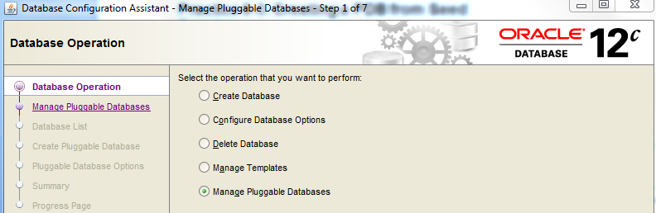
1. Click Next to Continue creation of a PDB.
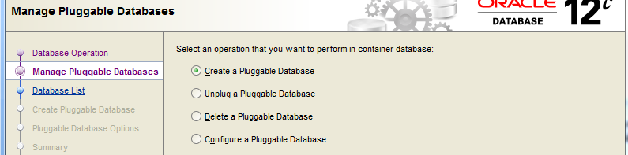
2. Select Create a Pluggable Database and Click Next.
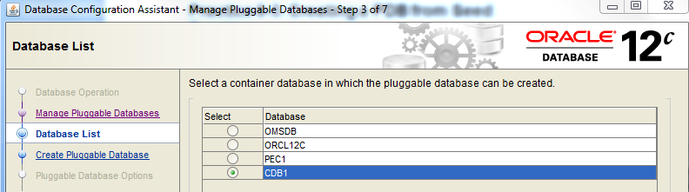
3. Select CDB1 as your container database for the new pluggable database to be created. Click Next.
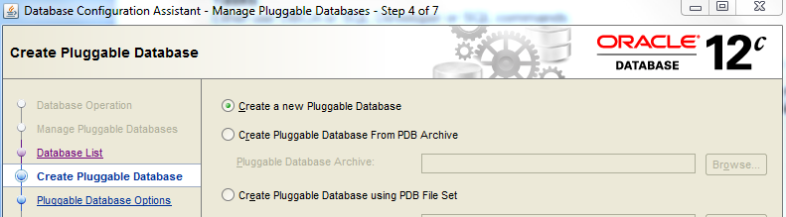
4. Select Create a New Pluggable database. You could also select to create a pluggable database from an Archive or from a PDB File Set that already exists such as PDB1_1. Click Next to continue pdb creation.
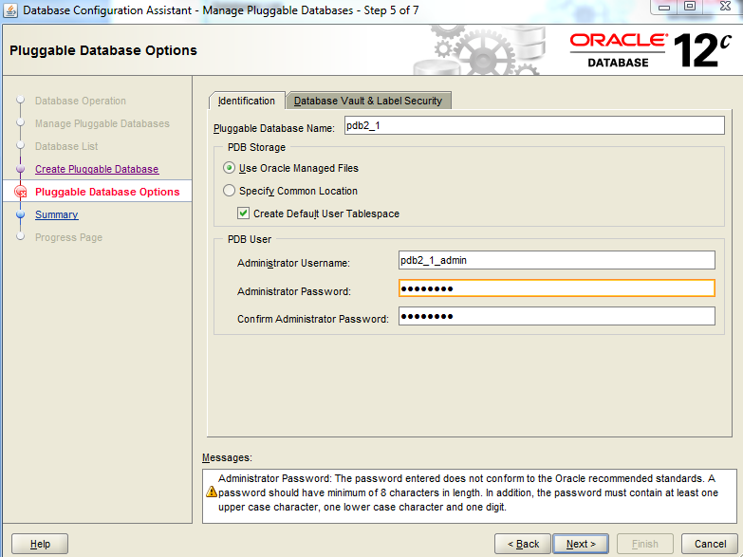
5. Select the appropriate PDB name, in our exercise PDB2_1 and identify an administrator for the new pluggable database called pdb2_1_admin with a password of password. CLick Next to continue.
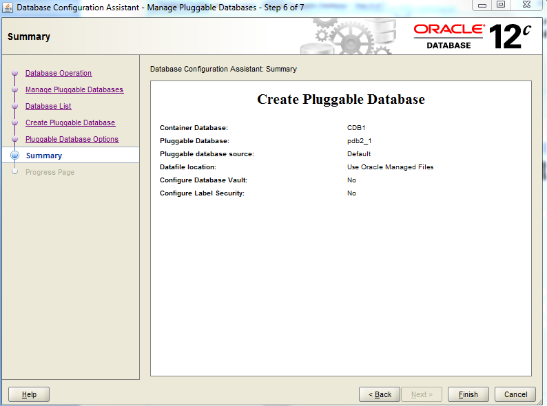
6. The last step is to review your DBCA Summary and Click on the Finish button.
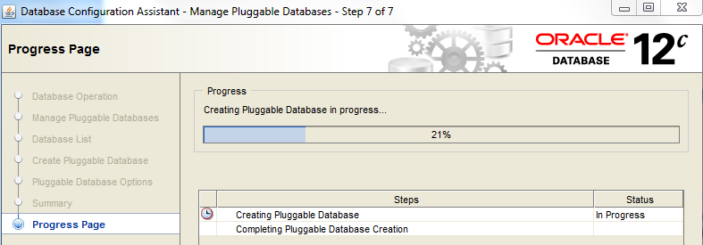
7. The Progress page will then be provided so the DBA can monitor the creation of the New Pluggable Database.
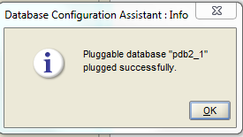
8. When complete a dialogue screen will appear to identify the database was successfully completed. The Pluggable database will automatically be opened with DBCA.
*******************************************************************************************************
The creation using SQL is described below. This is good for all installations but because we used OMF the filenames are too long. When creating the initial container database the DBA must specify the locations without using Oracles OMF file creation.
1. Create a directory for the new data files of pdb2_1 of cdb1.

cd c:\app\oracle\oradata\cdb1
c:\app\oracle\oradata\cdb1> mkdir pdb2_1

2. Run SQL*Plus and connect to the root with a user with CREATE PLUGGABLE DATABASE
privilege.

sqlplus / as sysdba
Connected to:
Oracle Database 12c Enterprise Edition Release 12.1.0.0.2 -
64bit Production
With the Partitioning, OLAP, Data Mining and Real Application
Testing options
SQL> CREATE PLUGGABLE DATABASE pdb2_1 ADMIN USER pdb2_1_admin
2 IDENTIFIED BY password ROLES=(CONNECT)
3 FILE_NAME_CONVERT=('c:\app\oracle\oradata\cdb1\pdbseed'
4 ,'c:\app\oracle\oradata\cdb1\pdb2_1');
Pluggable database created.
SQL>
3. Check the open mode of pdb2_1.

SQL> col con_id format 999
SQL> col name format A10
SQL> select con_id, NAME, OPEN_MODE,DBID, CON_UID from V$PDBS;
CON_ID NAME OPEN_MODE DBID CON_UID
------ ---------------------- ---------- ---------- ----------
2 PDB$SEED READ ONLY 4029890286 4029890286
3 PDB2_1 MOUNTED 3071827262 3071827262
SQL>

4. Open pdb2_1.
a. Open the PDB.

SQL> alter pluggable database pdb2_1 open;
Pluggable database altered.
SQL> EXIT
b. Connect to pdb2_1 AS SYSDBA.
1) Use netca to add the PDB2_1 net service name for pdb2_1 pluggable database of
cdb1 in the tnsnames.ora file.
From your desktop select START | All PROGRAMS | Oracle - OraDB12Home1 | Configuration Migration Tools | Net Configuration Assistant
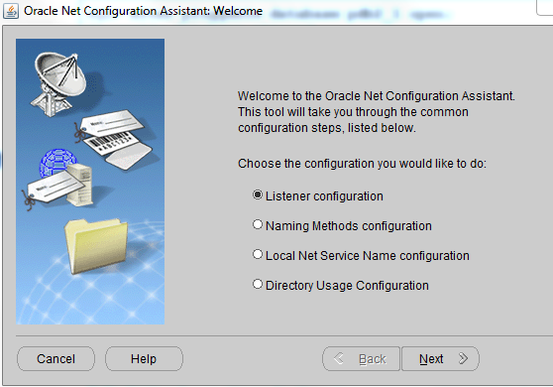
2) On the Welcome page, select the “Local Net Service Name configuration” and
click Next.
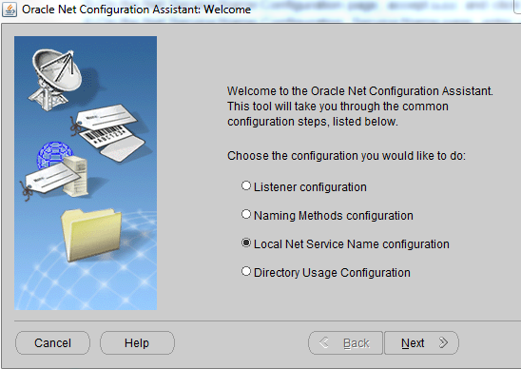

3) On the Net Service Name Configuration page, accept Add and click Next.
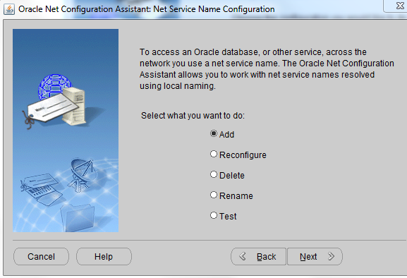
4) On the Net Service Name Configuration, Service Name page, enter pdb2_1 as
Service Name and click Next.
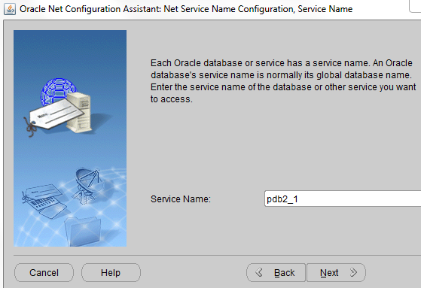
5) On the Net Service Name Configuration, Select Protocols page, select TCP and
click Next.
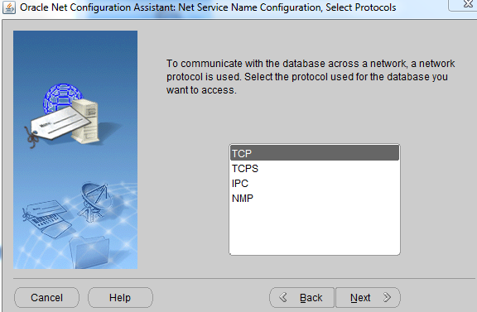
6) On the Net Service Name Configuration, TCP\IP Protocol page, enter your
complete host name, for example, <yourservername>, or localhost, accept
“Use the standard port number of 1521 or 1522,” and click Next.
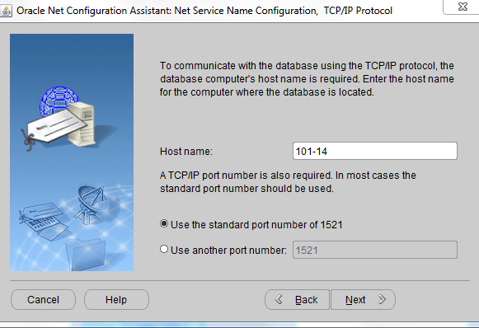
.
7) On the Net Service Name Configuration, Test page, select “No, do not test” (the
pluggable database is not yet opened nor is the scott user unlocked) and click Next

.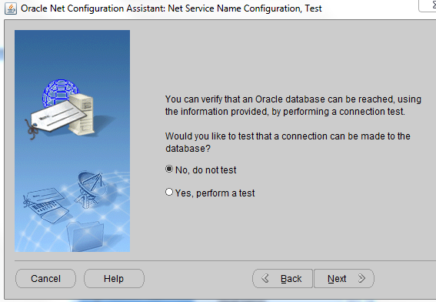

9) On the Net Service Name Configuration, Net Service Name page, accept pdb2_1 as Net Service Name and click Next t Service Name Configuration, Another Net Service Name page, select No, and Next.
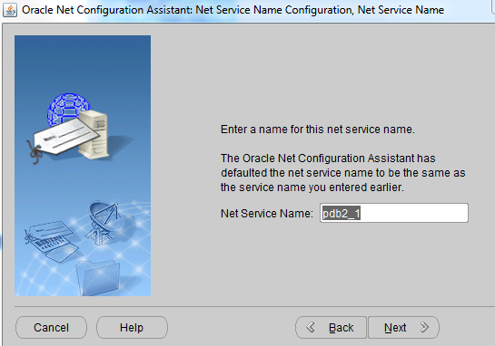
10) On the Net Service Name Configuration Done page, click Next.
11) When you are back on the Welcome page, click Finish. Log into sqlplus as shown below.
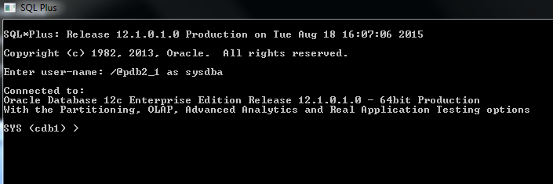

5. The service is now available and registered with the listener.

SQL> host
c:\ora12clabs> lsnrctl status
The command completed successfully
LSNRCTL for Linux: Version 12.1.0.0.2 - Production on 07-SEP-
2012 01:47:28
Copyright (c) 1991, 2012, Oracle. All rights reserved.
Connecting to
(DESCRIPTION=(ADDRESS=(PROTOCOL=IPC)(KEY=EXTPROC1521)))
STATUS of the LISTENER
------------------------
Alias LISTENER
Version TNSLSNR for Windows: Version 12.1.0.0.2 - Production
Start Date 14-SEP-2012 03:04:56
Uptime 16 days 22 hr. 0 min. 0 sec
Trace Level off
Security ON: Local OS Authentication
SNMP OFF
Listener Parameter File
c:\app\oracle\product\12.1.0\dbhome_1network\admin\listener.o
ra
Listener Log File
c:\app\oracle\diag\tnslsnr\yourserver\listener\alert\log.xml
Listening Endpoints Summary...
(DESCRIPTION=(ADDRESS=(PROTOCOL=ipc)(KEY=EXTPROC1521)))
(DESCRIPTION=(ADDRESS=(PROTOCOL=tcp)(HOST=yourserver)(PORT=1522)
))
(DESCRIPTION=(ADDRESS=(PROTOCOL=tcp)(HOST=yourserver)(PORT=5501)
)(Presentation=HTTP)(Session=RAW))
(DESCRIPTION=(ADDRESS=(PROTOCOL=tcp)(HOST=yourserver)(PORT=5502)
)(Presentation=HTTP)(Session=RAW))
(DESCRIPTION=(ADDRESS=(PROTOCOL=tcp)(HOST=yourserver)(PORT=5500)
)(Presentation=HTTP)(Session=RAW))
Services Summary...
Service "cdb1" has 1 instance(s).
Instance "cdb1", status READY, has 1 handler(s) for this
service...
Service "cdb1XDB" has 1 instance(s).
Instance "cdb1", status READY, has 1 handler(s) for this
service...
Service "cdb1" has 1 instance(s).
Instance "cdb1", status READY, has 1 handler(s) for this
.........................
service...
Service "cdb1XDB" has 1 instance(s).
Instance "cdb1", status READY, has 1 handler(s) for this
service...
Service "pdb1_1" has 1 instance(s).
Instance "cdb1", status READY, has 1 handler(s) for this
service.
Service "pdb2_1" has 1 instance(s).
Instance "cdb1", status READY, has 1 handler(s) for this
service.
The command completed successfully
SQL>

6. Connect to pdb2_1 as sys user by using EasyConnect and then as pdb2_1_admin user.

SQL> CONNECT sys/password@101-14:1521\pdb2_1 AS SYSDBA
Connected.
SQL> connect pdb2_1_admin\password@PDB2_1
Connected.
SQL> show con_name
CON_NAME
------------------------------
PDB2_1
SQL>
7. List the data files created.

SQL> host

C:\app\oracle\oradata\orcl12c\pdborcl>dir
Volume in drive C is Windows
Volume Serial Number is 967E-5726
Directory of C:\app\oracle\oradata\cdb1\pdb2_1

07/15/2015 11:24 PM <DIR> .
07/15/2015 11:24 PM <DIR> ..
08/13/2015 03:29 AM 375,529,472 EXAMPLE01.DBF
08/12/2015 10:00 PM 614,473,728 PDB$SEED_TEMP01.DBF
08/13/2015 03:29 AM 5,251,072 SAMPLE_SCHEMA_USERS01.DBF
08/13/2015 03:29 AM 671,096,832 SYSAUX01.DBF
08/13/2015 03:29 AM 408,952,832 SYSTEM01.DBF
5 File(s) 2,075,303,936 bytes
2 Dir(s) 495,203,090,432 bytes free
SQL>

8. Check the services, data files, and tablespaces using views.

SQL> connect system\PASSWORD@pdb2_1
Connected.
SQL> col name format A30
SQL> select name from v$services;
NAME
----------------------------
pdb2_1
SQL> col file_name format A50
SQL> col tablespace_name format A8
SQL> col file_id format 99
SQL> col con_id format 9
SQL> select FILE_NAME, TABLESPACE_NAME, FILE_ID, con_id 2 from cdb_data_files
3 order by con_id ;
FILE_NAME TS_NAME FILE_ID CON_ID
------------------------------------------------ -------- ------- ------
c:\app\oracle\oradata\cdb1\pdb2_1\sysaux01.dbf SYSAUX 9 3
c:\app\oracle\oradata\cdb1\pdb2_1\system01.dbf SYSTEM 8 3
SQL> select FILE_NAME, TABLESPACE_NAME, FILE_ID
2 from dba_data_files;
FILE_NAME TABLESPANAME FILE_ID
-------------------------------------------------- ----------- ------
c:\app\oracle\oradata\cdb1\pdb2_1\system01.dbf SYSTEM 8
c:\app\oracle\oradata\cdb1\pdb2_1\sysaux01.dbf SYSAUX 9
SQL> col file_name format A60
SQL> select FILE_NAME, TABLESPACE_NAME, FILE_ID
2 from cdb_temp_files;
FILE_NAME TABLESPACE NAME FILE_ID
-------------------------------------------------- ------------- -------
c:\app\oracle\oradata\cdb1\pdb2_1\pdbseed_temp01.dbf TEMP 3

SQL> select FILE_NAME, TABLESPACE_NAME, FILE_ID
2 from dba_temp_files;
FILE_NAME TS_NAME FILE_ID
----------------------------------------------------- ------- -------
c:\app\oracle\oradata\cdb1\pdb2_1\ pdbseed_temp01.dbf TEMP 3
SQL>

9. To be able to view all objects of all containers in the CDB, connect to the root and use
CDB_xxx views.

SQL> connect \ as sysdba
Connected.
SQL> show con_id
CON_ID
------------------------------
1
SQL> show con_name
CON_NAME
------------------------------
CDB$ROOT
SQL> select name from v$services;
NAME
------------------------------
pdb2_1
cdb1XDB
cdb1
SYS$BACKGROUND
SYS$USERS

SQL> select FILE_NAME, TABLESPACE_NAME, FILE_ID, con_id
2 from cdb_data_files
3 order by con_id, file_id ;

FILE_NAME TS_NAME FILE_ID CON_ID
-------------------------------------------------- -------- ------ ------
c:\app\oracle\oradata\cdb1\system01.dbf SYSTEM 1 1
c:\app\oracle\oradata\cdb1\sysaux01.dbf SYSAUX 3 1
c:\app\oracle\oradata\cdb1\undotbs01.dbf UNDOTBS1 4 1
c:\app\oracle\oradata\cdb1\users01.dbf USERS 6 1
c:\app\oracle\oradata\cdb1\pdbseed\system01.dbf SYSTEM 5 2
c:\app\oracle\oradata\cdb1\pdbseed\sysaux01.dbf SYSAUX 7 2
c:\app\oracle\oradata\cdb1\pdb2_1\system01.dbf SYSTEM 8 3
c:\app\oracle\oradata\cdb1\pdb2_1\sysaux01.dbf SYSAUX 9 3
8 rows selected.

SQL> select FILE_NAME, TABLESPACE_NAME, FILE_ID
2 from dba_data_files;
FILE_NAME TABLESPASPACE_NAME FILE_ID
---------------------------------------------- ------------------ -------
c:\app\oracle\oradata\cdb1\users01.dbf USERS 6
c:\app\oracle\oradata\cdb1\undotbs01.dbf UNDOTBS1 4
c:\app\oracle\oradata\cdb1\sysaux01.dbf SYSAUX 3
c:\app\oracle\oradata\cdb1\system01.dbf SYSTEM 1
SQL> select FILE_NAME, TABLESPACE_NAME, FILE_ID
2 from cdb_temp_files;
FILE_NAME TABLESPACE_NAME FILE_ID
----------------------------------------------------- -------------- ------
c:\app\oracle\oradata\cdb1\temp01.dbf TEMP 1
c:\app\oracle\oradata\cdb1\pdbseed\pdbseed_temp01.dbf TEMP 2
c:\app\oracle\oradata\cdb1\pdb2_1\pdbseed_temp01.dbf TEMP 3
SQL> select FILE_NAME, TABLESPACE_NAME, FILE_ID
2 from dba_temp_files;
FILE_NAME TABLESPACE_NAME FILE_ID
---------------------------------------------- --------------- -------
c:\app\oracle\oradata\cdb1\temp01.dbf TEMP 1
SQL> EXIT

Practice 6-4: Cloning PDB Within the Same CDB
Overview
In this practice, you will create a new PDB with the cloning method, cloning pdb2_2 from
pdb2_1 within the same CDB cdb1.
Assumptions
The pdb2_1 creation has completed successfully in Practice 8-3.
Tasks
Either use the SQL commands OR SQL Developer. Below is the Method with SQL*Plus.
1. Create a directory for the new data files of pdb2_2 of cdb1.
c:\ora12clabs> cd C:\app\oracle\oradata\cdb1
$ mkdir pdb2_2
2. Run SQL*Plus and connect as a user granted with CREATE PLUGGABLE DATABASE privilege.
Connect as sys in the cdb1 container database.
a. Set pdb2_1 in READ ONLY open mode before cloning.
$ sqlplus \ as sysdba
Connected to:
Oracle Database 12c Enterprise Edition Release 12.1.0.0.2 -
64bit Production
With the Partitioning, OLAP, Advanced Analytics and Real
Application Testing options
SQL> alter pluggable database pdb2_1 close;
Pluggable database altered.
SQL> alter pluggable database pdb2_1 open read only;
Pluggable database altered.
SQL>
b. Change OMF DB_CREATE_FILE_DEST parameter value to 'c:\app\oracle\oradata\cdb1\pdb2_2'.
SQL> alter system set db_create_file_dest =
'c:\app\oracle\oradata\cdb1\pdb2_2';
System altered.
SQL>
c. Clone pdb2_2 from pdb2_1.
SQL> CREATE PLUGGABLE DATABASE pdb2_2 FROM pdb2_1;
Pluggable database created.
SQL>

3. Check the open mode of pdb2_2.

SQL> select name, open_mode from v$pdbs;
NAME OPEN_MODE
------------------------------ ----------
PDB$SEED READ ONLY
PDB2_1 READ ONLY
PDB2_2 MOUNTED
SQL>
4. Set PDB2_1 in READ WRITE open mode and open PDB2_2.
a. Open PDB2_1 in READ WRITE mode.

SQL> alter pluggable database PDB2_1 close;
Pluggable database altered.
SQL> alter pluggable database PDB2_1 open;
Pluggable database altered.
SQL>

b. Open PDB2_2 in READ WRITE mode.

SQL> alter pluggable database PDB2_2 open;
Pluggable database altered.
SQL> EXIT

c. Connect to pdb2_2 AS SYSDBA.
1) Use netca to add the PDB2_2 net service name for pdb2_2 pluggable database of
cdb1 in the tnsnames.ora file.
Start | All Programs | Oracle - OraDB12Home1 | Configuration Migration Tools | Net Configuration Assistant
2) On the Welcome page, select the “Local Net Service Name configuration” and
click Next.
3) On the Net Service Name Configuration page, accept Add and click Next.
4) On the Net Service Name Configuration, Service Name page, enter pdb2_2 as
Service Name and click Next.
5) On the Net Service Name Configuration, Select Protocols page, select TCP and
click Next.
6) On the Net Service Name Configuration, TCP\IP Protocol page, enter your
complete host name, for example, <yourservername>, or localhost, accept
“Use the standard port number of 1522,” and click Next.
7) On the Net Service Name Configuration, Test page, select “No, do not test” (the
pluggable database is not yet opened) and click Next.
8) On the Net Service Name Configuration, Net Service Name page, accept pdb2_2
as Net Service Name and click Next.
9) On the Net Service Name Configuration, Another Net Service Name page, select
No, and Next.
10) On the Net Service Name Configuration Done page, click Next.
11) When you are back on the Welcome page, click Finish.
From your desktop select sqlplus with user id sys\password@pdb2_2 AS SYSDBA
Connected to:
Oracle Database 12c Enterprise Edition Release 12.1.0.0.2 -
64bit Production
With the Partitioning, OLAP, Advanced Analytics and Real
Application Testing options
SQL>
d. Check the open mode of the PDBs.
SQL> CONNECT / AS SYSDBA
Connected.
SQL> select name, open_mode from v$pdbs;
NAME OPEN_MODE
------------------------------ ----------
PDB$SEED READ ONLY
PDB2_1 READ WRITE
PDB2_2 READ WRITE
SQL>
5. Connect to PDB2_2 as the SYSTEM user.
SQL> connect system/password@PDB2_2
Connected.
SQL> show con_name
PDB2_2
SQL> EXIT

6. List the data files created.

C:\ora11glabs>cd c:\app\oracle\oradata\cdb1
c:\app\oracle\oradata\CDB1>dir
Volume in drive C is Windows
Volume Serial Number is 967E-5726

Directory of c:\app\oracle\oradata\CDB1

08/19/2015 09:18 AM <DIR> .
08/19/2015 09:18 AM <DIR> ..
08/18/2015 02:42 PM <DIR> 9925B47F62FE4AD488E133D230DC3C0C
08/18/2015 09:33 AM <DIR> 9E03ED8956664A0B82A5360632CAEDA7
08/18/2015 09:26 AM <DIR> CONTROLFILE
08/18/2015 09:27 AM <DIR> DATAFILE
08/18/2015 09:26 AM <DIR> ONLINELOG
08/18/2015 01:39 PM <DIR> pdb2_1
08/19/2015 09:33 AM <DIR> pdb2_2
08/18/2015 02:55 PM <DIR> pdb3_1
0 File(s) 0 bytes
10 Dir(s) 489,793,118,208 bytes free

c:\app\oracle\oradata\CDB1>cd pdb2_2

c:\app\oracle\oradata\CDB1\pdb2_2>dir
Volume in drive C is Windows
Volume Serial Number is 967E-5726

Directory of c:\app\oracle\oradata\CDB1\pdb2_2

08/19/2015 09:33 AM <DIR> .
08/19/2015 09:33 AM <DIR> ..
08/19/2015 09:33 AM <DIR> CDB1
0 File(s) 0 bytes
3 Dir(s) 489,143,463,936 bytes free
c:\app\oracle\oradata\CDB1\pdb2_2>cd CDB1

c:\app\oracle\oradata\CDB1\pdb2_2\CDB1>dir
Volume in drive C is Windows
Volume Serial Number is 967E-5726

Directory of c:\app\oracle\oradata\CDB1\pdb2_2\CDB1

08/19/2015 09:33 AM <DIR> .
08/19/2015 09:33 AM <DIR> ..
08/19/2015 09:33 AM <DIR> EE2D35BFF54C454599D253471A500150
0 File(s) 0 bytes
3 Dir(s) 489,143,373,824 bytes free

c:\app\oracle\oradata\CDB1\pdb2_2\CDB1>cd EE*.

c:\app\oracle\oradata\CDB1\pdb2_2\CDB1\EE2D35BFF54C454599D253471A500150>dir
Volume in drive C is Windows
Volume Serial Number is 967E-5726

Directory of c:\app\oracle\oradata\CDB1\pdb2_2\CDB1\EE2D35BFF54C454599D253471A500150

08/19/2015 09:33 AM <DIR> .
08/19/2015 09:33 AM <DIR> ..
08/19/2015 09:34 AM <DIR> DATAFILE
0 File(s) 0 bytes
3 Dir(s) 489,143,361,536 bytes free
c:\app\oracle\oradata\CDB1\pdb2_2\CDB1\EE2D35BFF54C454599D253471A500150>cd datafile

c:\app\oracle\oradata\CDB1\pdb2_2\CDB1\EE2D35BFF54C454599D253471A500150\DATAFILE>dir
Volume in drive C is Windows
Volume Serial Number is 967E-5726

Directory of c:\app\oracle\oradata\CDB1\pdb2_2\CDB1\EE2D35BFF54C454599D253471A500150\DATAFILE

08/19/2015 09:34 AM <DIR> .
08/19/2015 09:34 AM <DIR> ..
08/19/2015 09:53 AM 650,125,312 O1_MF_SYSAUX_BX94YM9J_.DBF
08/19/2015 09:53 AM 262,152,192 O1_MF_SYSTEM_BX94YM9H_.DBF
08/19/2015 09:34 AM 20,979,712 O1_MF_TEMP_BX94ZHH0_.DBF
08/19/2015 09:53 AM 5,251,072 O1_MF_USERS_BX94YM9G_.DBF
4 File(s) 938,508,288 bytes
2 Dir(s) 489,143,345,152 bytes free

Method with SQL Developer: (Optional)
1. If you already created pdb2_2 with SQL*Plus and would like to test the creation with SQL
Developer, you first have to drop pdb2_2 to recreate it.
a. Drop the pluggable database pdb2_2.
From your desktop click on sqlplus and login as SYS

SQL> / AS SYSDBA
Connected to:
Oracle Database 12c Enterprise Edition Release 12.1.0.0.2 -
64bit Production
With the Partitioning, OLAP, Advanced Analytics and Real
Application Testing options
SQL> ALTER PLUGGABLE DATABASE pdb2_2 CLOSE IMMEDIATE;
Pluggable database altered.
SQL> DROP PLUGGABLE DATABASE pdb2_2 INCLUDING DATAFILES;
Pluggable database dropped.
SQL> EXIT

b. Remove the directory.- In WIndows delete the files inside the pdb2_2 directory.
c:\ora12clabs> del c:\app\oracle\oradata\cdb1\pdb2_2
OR use your GUI tool (computer icon on desktop) to move to the location and delete
2. Create a directory for the new data files of pdb2_2 of cdb1.
c:\ora12clabs> cd c:\app\oracle\oradata\cdb1
c:\ora12clabs> mkdir pdb2_2

3. Run SQL*Plus and connect to the root to set OMF directory to the pdb2_2 directory.
From your desktop, click on your sqlplus icon and log in as SYS

SQL> \ AS SYSDBA
Connected to:
Oracle Database 12c Enterprise Edition Release 12.1.0.0.2 -
64bit Production
With the Partitioning, OLAP, Advanced Analytics and Real
Application Testing options
SQL> alter system set db_create_file_dest =
'c:\app\oracle\oradata\cdb1\pdb2_2' scope=both;
System altered.
SQL> EXIT

4. Launch SQL Developer.
From desktop, double click on the sqldeveloper icon
5. Create a connection as SYS in cdb1.
6. Open a connection as SYS in cdb1.
a. Choose the View option.
b. Click Connections.
c. Click + in the left Connections pane to add a new connection.
d. Fill the different fields as follows: be sure to change the host name and port number to
your assigned host name and port number
.

Window\Page Description Choices or Values
Connection Name cdb1_SYS
Username sys
Password password
Connection Type TNS
Role SYSDBA
Network Alias cdb1

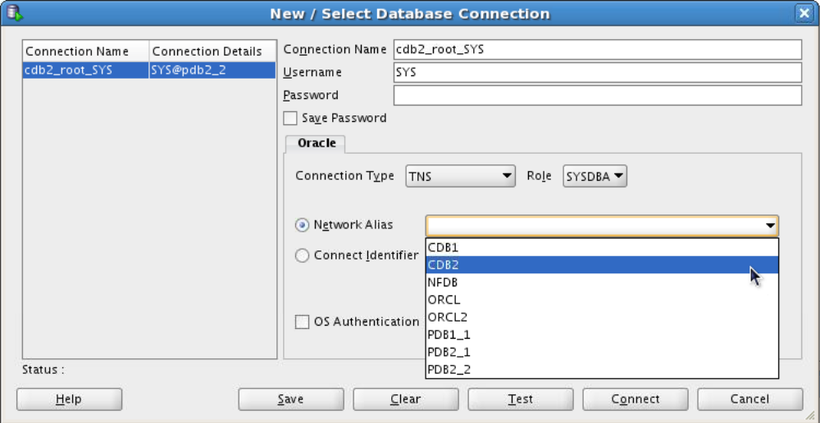
cdb1_sys
7. To manage the CDB and its PDBs:
a. Choose the View option.
b. Click DBA.
c. Click + in the left Connections pane to view an existing connection.
d. From the list of existing connections, choose the one you just created.
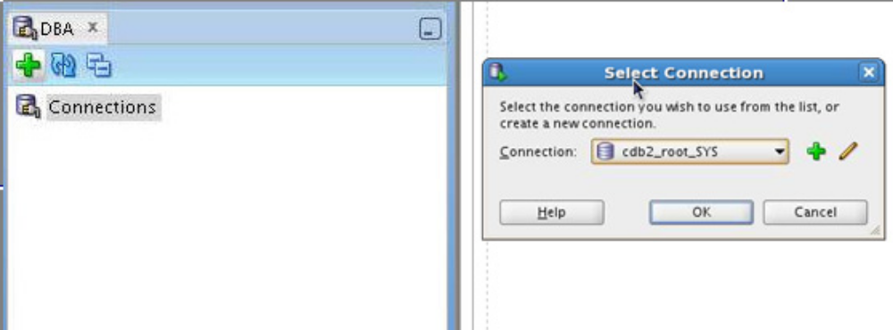
cdb1_sys

e. Click OK.
f. Click the sign + in front of the name of the cdb1_SYS connection to expand the
folder. Then click the sign + in front of “Container Database”. The list of containers in
the CDB appears.
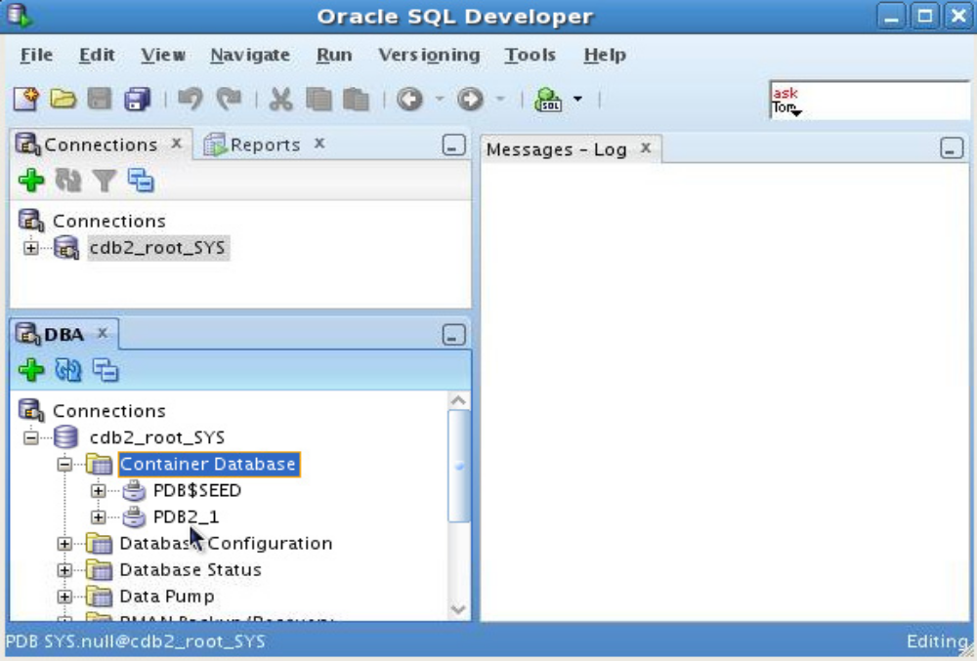
cdb1_sys
cdb1_sys
8. Right-click the pluggable database pdb2_1 to show possible actions.
Choose Modify State to set it in READ ONLY open mode before cloning.
a. First close
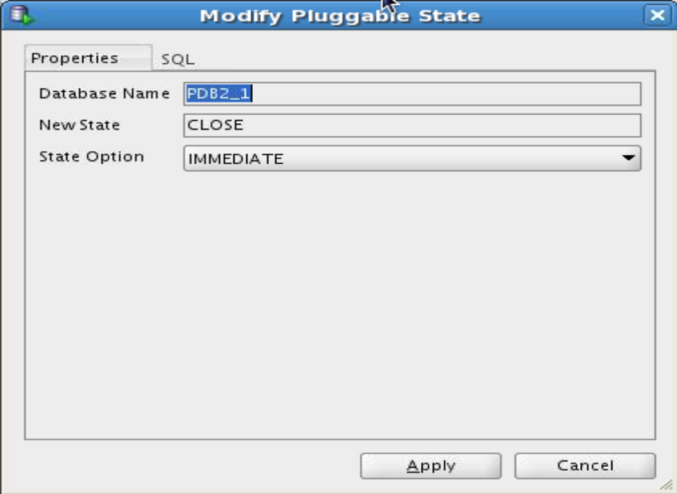

b. Click Apply.
c. Choose Modify State again.
d. Set the State Option to READ ONLY.
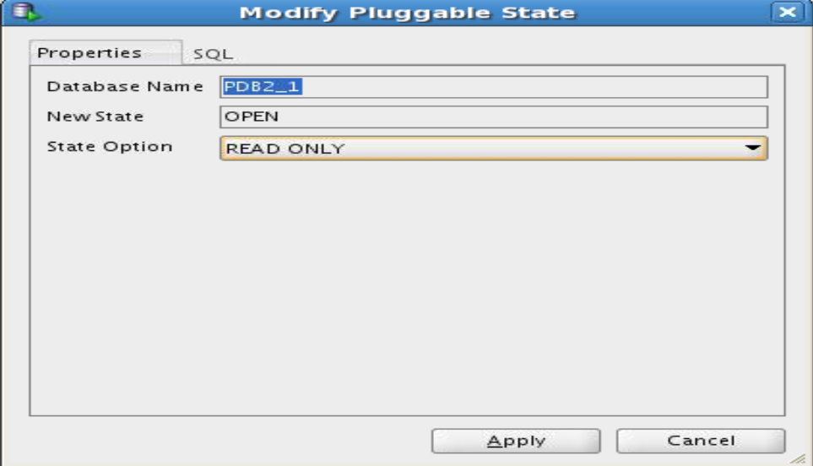
e. Click Apply then OK.
9. Right-click the pluggable database pdb2_1 and choose Clone Pluggable Database….
a. Fill the different fields as follows.

Window\Page Description Choices or Values
Database Name pdb2_2
Source PDB pdb2_1
File Name Conversions None

File Name Conversions kept to None means that it uses the OMF target destination
declared in DB_CREATE_FILE_DEST parameter.
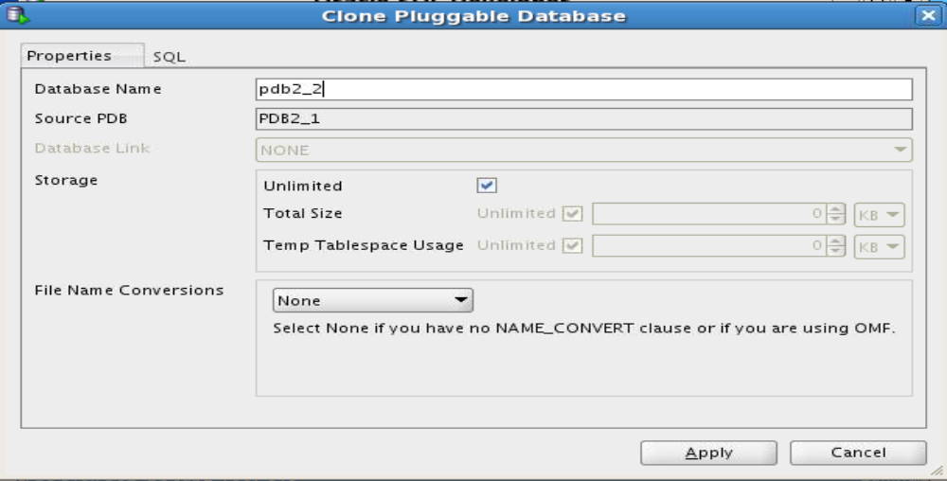

b. You can view the SQL statement before applying.
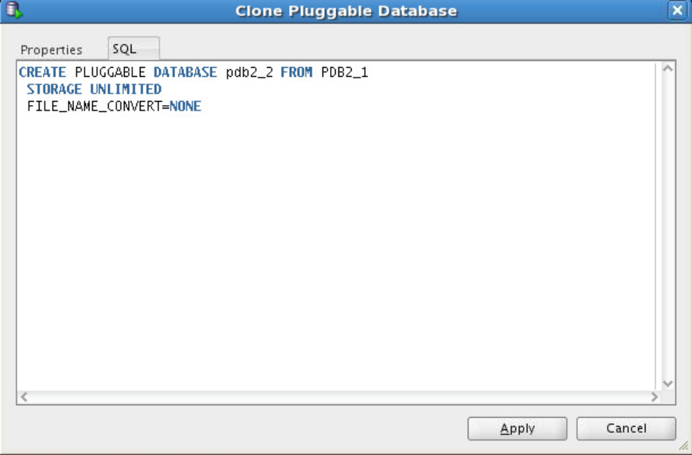
c. Click Apply then OK. The new pdb2_2 appears in the list of PDBs in cdb1.
d. Open pdb2_2.

1) Open pdb2_2 in READ WRITE mode. Right click pdb2_2 and click Modify State.
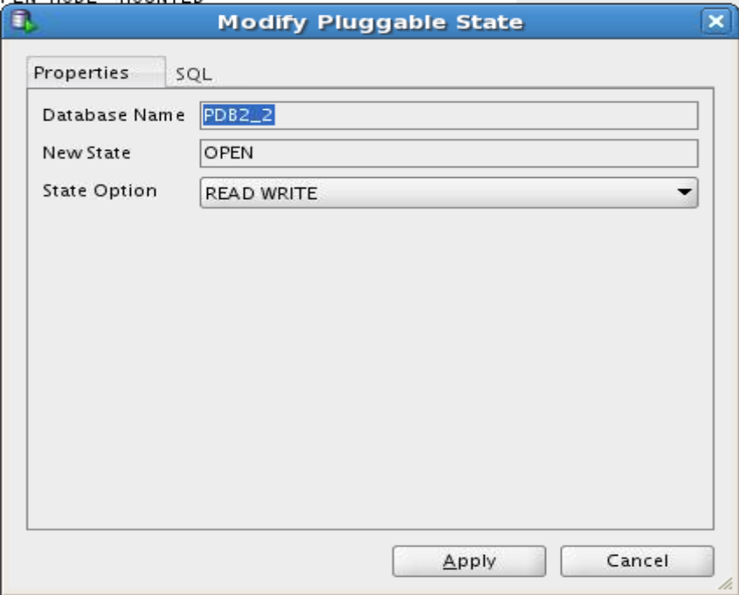

2) Click Apply, then OK.
e. Open pdb2_1 in READ WRITE mode. Right click pdb2_1 and click Modify State. Click
Apply , then OK.
10. Leave SQL Developer.
a. Click File.
b. Then click exit.
Practice 6-5: Plugging a Non-CDB into a CDB
Overview
In this practice, you will plug the non-CDB pec1 into the CDB cdb1. You will not use Export\ Import DataPump, which can be a possible method, but the method with DBMS_PDB package. This package executed in the non-CDB pec1 generates an XML file describing the tablespaces and data files of non-CDB pec1. The XML file is then used when creating pdb_pec1 in cdb1.
Tasks
1. Use DBMS_PDB.DESCRIBE to “unplug” non-CDB pec1.

$ sqlplus as sysdba
Connected to an idle instance.
SQL> startup mount
ORACLE instance started.
Total System Global Area 1670221824 bytes
Fixed Size 2274000 bytes
Variable Size 973081904 bytes
Database Buffers 687865856 bytes
Redo Buffers 7000064 bytes
Database mounted.
SQL>
SQL> alter database open read only;
Database altered.
SQL> exec dbms_pdb.describe
('c:\app\oracle\oradata\pec1\xmlpec1.xml')
PL\SQL procedure successfully completed.
SQL> shutdown immediate
Database closed.
Database dismounted.
ORACLE instance shut down.
SQL> EXIT
c:\ora12clabs
2. Create a new PDB pdb_pec1 to plug non-CDB pec1 into cdb1 using the XML file
generated.
You will have to remove the temp file because the creation cannot complete until it is
removed to create it.

$ sqlplus / as sysdba
Connected to:
Oracle Database 12c Enterprise Edition Release 12.1.0.0.2 -
64bit Production
With the Partitioning, OLAP, Data Mining and Real Application
Testing options
SQL> create pluggable database PDB_pec1 using
'c:\app\oracle\oradata\pec1\datafile\xmlpec1.xml' NOCOPY;
create pluggable database PDB_pec1 using 'xmlpec1' NOCOPY
*
ERROR at line 1:
ORA-01119: error in creating database file
'c:\app\oracle\oradata\pec1\datafile\01_MF_TEMP_BVYVRWFK_.TMP
ORA-27038: created file already exists
Additional information: 1
SQL>DEL c:\app\oracle\oradata\pec1\datafile\01_MF_TEMP_BVYVRWFK_.TMP
SQL>
SQL> create pluggable database PDB_pec1 using
'c:\app\oracle\oradata\PEC1\datafile\xmlpec1.xml' NOCOPY;
Pluggable database created.
SQL> EXIT
c:\ora12clabs>

3. To complete the operation, you have to convert the plugged non-CDB to a proper PDB by
deleting unnecessary metadata from PDB SYSTEM tablespace. For this purpose, you execute the
c:\app\oracle\product\12.1.0\dbhome_1\rdbms\admin\noncdb_to_pdb.sql
script whilst connected to the PDB.
a. Connect to pdb2_2 as SYSDBA.
1) Use netca to add the PDB_ORCL2 net service name for pdb_orcl2 pluggable
database of cdb1 in the tnsnames.ora file.
From your desktop: Start | All Programs | Oracle - OraDB12Home1 | Configuration Migration Tools | Net Configuration Assistant
2) On the Welcome page, select the “Local Net Service Name configuration” and click Next.
3) On the Net Service Name Configuration page, accept Add and click Next.
4) On the Net Service Name Configuration, Service Name page, enter pdb_pec1
as Service Name and click Next.
5) On the Net Service Name Configuration, Select Protocols page, select TCP and
click Next.
6) On the Net Service Name Configuration, TCP\IP Protocol page, enter your
complete host name, for example, <yourservername>, or localhost, accept
“Use the standard port number of 1522,” and click Next.
7) On the Net Service Name Configuration, Test page, select “No, do not test” (the
pluggable database is not yet opened) and click Next.
8) On the Net Service Name Configuration, Net Service Name page, accept
pdb_pec1 as Net Service Name and click Next.
9) On the Net Service Name Configuration, Another Net Service Name page, select
No, and Next.
10) On the Net Service Name Configuration Done page, click Next.
11) When you are back on the Welcome page, click Finish.
b. Now connect to pdb_pec1 using the net service name.

$ sqlplus sys/password@pdb_pec1 as sysdba
Connected to:
Oracle Database 12c Enterprise Edition Release 12.1.0.0.2 -
64bit Production
With the Partitioning, OLAP, Advanced Analytics and Real
Application Testing options
SQL>
c. Execute the script. Expect around 35 minutes to complete.

SQL> c:\app\oracle\product\12.1.0\dbhome_1\rdbms\admin\noncdb_to_pdb.sql
SQL> SET SERVEROUTPUT ON
SQL> SET FEEDBACK 1
SQL> SET NUMWIDTH 10
SQL> SET LINESIZE 80
SQL> SET TRIMSPOOL ON
SQL> SET TAB OFF
SQL> SET PAGESIZE 100
SQL>
SQL> WHENEVER SQLERROR EXIT;
SQL>
SQL> DOC
DOC>############################################################
###########
DOC>############################################################
DOC> The following statement will cause an "ORA-01722: invalid
number"
DOC> error if we're not in a PDB.
DOC>############################################################
DOC>############################################################
DOC>#
SQL>
SQL> VARIABLE pdbname VARCHAR2(128)
SQL> BEGIN
2 SELECT sys_context('USERENV', 'CON_NAME')
3 INTO :pdbname
4 FROM dual
5 WHERE sys_context('USERENV', 'CON_NAME') <> 'CDB$ROOT';
6 END;
7 \
PL\SQL procedure successfully completed.
…
SQL>
SQL> Rem
================================================================
SQL> Rem Run component validation procedure
SQL> Rem
================================================================
SQL>
SQL> EXECUTE dbms_registry_sys.validate_components;
...Database user "SYS", database schema "APEX_040200", user#
"98" 10:21:02
...Compiled 0 out of 2998 objects considered, 0 failed
compilation 10:21:03
...263 packages
...255 package bodies
...453 tables
...11 functions
...16 procedures
...3 sequences
...458 triggers
...1322 indexes
...207 views
...0 libraries
...6 types
...0 type bodies
...0 operators
...0 index types
...Begin key object existence check 10:21:03
...Completed key object existence check 10:21:03
...Setting DBMS Registry 10:21:03
...Setting DBMS Registry Complete 10:21:03
...Exiting validate 10:21:03
PL\SQL procedure successfully completed.
SQL> SET serveroutput off
SQL>
SQL> Rem
================================================================
SQL> Rem END utlrp.sql
SQL> Rem
================================================================
SQL>
SQL> alter pluggable database "&pdbname" close;
Pluggable database altered.
SQL>
SQL> -- leave the PDB in the same state it was when we started
SQL> BEGIN
2 execute immediate '&open_sql &restricted_state';
3 EXCEPTION
4 WHEN OTHERS THEN
5 BEGIN
6 IF (sqlcode <> -900) THEN
7 RAISE;
8 END IF;
9 END;
10 END;
11 \
PL\SQL procedure successfully completed.
SQL>
SQL> alter session set container="&pdbname";
Session altered.
SQL>
SQL> WHENEVER SQLERROR CONTINUE;
SQL>

d. Quit the session after opening the new PDB.

SQL> alter pluggable database pdb_pec1 open;
Pluggable database altered.
SQL> EXIT
$
4. Connect to PDB_pec1.
$ sqlplus sys\password@101-xx:1521\PDB_PEC1 as SYSDBA
Connected to:
Oracle Database 12c Enterprise Edition Release 12.1.0.0.2 -
64bit Production
With the Partitioning, OLAP, Advanced Analytics and Real
Application Testing options
SQL>

5. Verify that the application data is in the PDB pdb_pec1

SQL> select count(empno) from scott.emp;
COUNT(EMPNO)
------------
14
SQL> EXIT

Practice 6-6: Merging All PDBs of CDBs into a Single CDB
Overview
In this practice you merge all PDBs of orcl12c into a single CDB, cdb1.
1. Merge all PDBs of orcl12c into cdb1.
2. Drop orcl12c.
Assumptions
The CDB cdb1 and orcl12c exists. The cdb1 creation has completed successfully in Practice 8-1.
Tasks
1. Connect to the multitenant container database orcl12c to unplug all PDBs.
a. Connect to orcl12c root as a common user with ALTER PLUGGABLE DATABASE
privilege to unplug pdborcl. If the pdborcl is still in READ WRITE mode, close the PDB.

$ sqlplus /@orcl12c as sysdba
Connected to:
Oracle Database 12c Enterprise Edition Release 12.1.0.0.2 -
64bit Production
With the Partitioning, OLAP, Data Mining and Real Application
Testing options
SQL> select name, open_mode from v$pdbs;
NAME OPEN_MODE
------------------------------ ----------
PDB$SEED READ ONLY
PDBorcl READ WRITE
SQL> alter pluggable database PDBorcl unplug into
'xmlfilePDBorcl.xml';
alter pluggable database PDBorcl unplug into 'xmlfilePDBorcl'
*
ERROR at line 1:
ORA-65025: Pluggable database PDBorcl is not closed on all
instances.
SQL> alter pluggable database PDBorcl close immediate;
Pluggable database altered.
SQL> alter pluggable database PDBorcl unplug into
'xmlfilePDBorcl.xml';
Pluggable database altered.
SQL> col PDB_NAME format A20
SQL> select PDB_NAME, STATUS from CDB_PDBS
where PDB_NAME='PDBorcl';
PDB_NAME STATUS
-------------------- -------------
PDB1_1 UNPLUGGED
SQL> drop pluggable database PDBorcl KEEP DATAFILES;
Pluggable database dropped.
SQL> EXIT

b. Before plugging pdborcl into cdb1, you can optionally check whether the unplugged
pdborcl is compatible with cdb1 with DBMS_PDB.CHECK_PLUG_COMPATIBILITY
function. Connect to cdb1 root as a common user with CREATE PLUGGABLE
DATABASE privilege to plug pdborcl.
Use the following PL\SQL code:

DECLARE
compat BOOLEAN := FALSE;
BEGIN
compat := DBMS_PDB.CHECK_PLUG_COMPATIBILITY(
pdb_descr_file =>
'c:\app\oracle\product\12.1.0\dbhome_1dbs\xmlfilePDBorcl.xml',
pdb_name => 'pdborcl');
if compat then
DBMS_OUTPUT.PUT_LINE('Is pluggable compatible? YES');
else DBMS_OUTPUT.PUT_LINE('Is pluggable compatible? NO');
end if;
end;
/
$ sqlplus / as sysdba
Connected.
SQL> SET SERVEROUTPUT ON
SQL> DECLARE
2 compat BOOLEAN := FALSE;
3 BEGIN
4 compat := DBMS_PDB.CHECK_PLUG_COMPATIBILITY(
5 pdb_descr_file =>
'c:\app\oracle\product\12.1.0\dbhome_1dbs\xmlfilePDBorcl.xml',
pdb_name => 'pdborcl');
6 if compat then
7 DBMS_OUTPUT.PUT_LINE('Is pluggable compatible? YES');
8 else DBMS_OUTPUT.PUT_LINE('Is pluggable compatible? NO');
9 end if;
10 end;
11 /
Is pluggable compatible? NO
PL\SQL procedure successfully completed.
SQL>

c. If the value returned is YES, you can immediately proceed with step d.
If the value returned is NO, examine the PDB_PLUG_IN_VIOLATIONS view to see why
it is not compatible.

SQL> select message, action from pdb_plug_in_violations
where name='PDBorcl';
MESSAGE
----------------------------------------------------------------
-
ACTION
----------------------------------------------------------------
-
Parameter sga_target mismatch: Previous value 503316480. CDB
value 5033164800
Change the parameter in PDB or the CDB
Parameter pga_aggregate_target mismatch: Previous value
167772160. CDB value 1677721600
Change the parameter in PDB or the CDB
SQL>

The message refers to a parameter related to PGA. The parameter will not have any
impact if you create the PDB. You can proceed with the creation of the PDB.
d. Plug pdborcl into cdb1.

SQL> create pluggable database pdb1_1 using 'xmlfilePDBorcl.xml'
NOCOPY;
Pluggable database created.
SQL>

Notice that you use the clause NOCOPY because the cdb1 pdb1_1 files are located in the
right place. Otherwise, you should have described the target destination to move the files
from the source to the new destination.
e. Open pdborcl.

SQL> alter pluggable database pdborcl open;
Pluggable database altered.
SQL>
f. Check that the pdborcl is in the PDBs list in cdb1.
SQL> select name, open_mode from v$pdbs;
NAME OPEN_MODE
------------------------------ ----------
PDB$SEED READ ONLY
PDB2_1 READ WRITE
PDB2_2 READ WRITE
PDB_ORCL2 READ WRITE
PDB1_1 READ WRITE
SQL> EXIT

2. After all PDBs are unplugged from orcl12c (in case you had created other PDBs) and
plugged into cdb1, you can drop the multitenant container database orcl12c with DBCA or SQL commands.

$ sqlplus /@orcl12c as sysdba
Connected.
SQL> shutdown immediate
Database closed.
Database dismounted.
ORACLE instance shut down.
SQL> startup mount restrict
ORACLE instance started.
Total System Global Area 722366464 bytes
Fixed Size 2276928 bytes
Variable Size 213909952 bytes
Database Buffers 503316480 bytes
Redo Buffers 2863104 bytes
Database mounted.
SQL> DROP DATABASE;
Database dropped.
SQL> EXIT

